Rouhani opens ‘strategic’ rail line near Iraqi border
Tue Mar 20, 2018 01:31PM
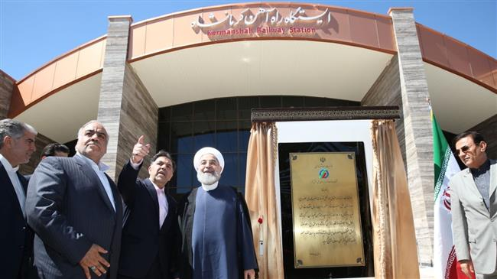

President Hassan Rouhani on Tuesday opened a new train line, linking a major city near the border with Iraq to the national railway network.
The railway to Kermanshah in western Iran ended 27 years of anticipation for the mainly-Kurdish city to have an alternative transportation mode and for the project to be completed.
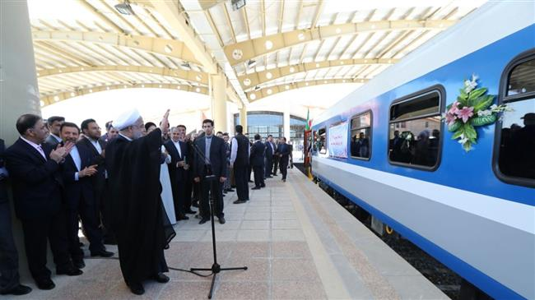 President Rouhani waves as the train arrives at Kermanshah railway station for the first time on March 20, 2018. (Photo by IRNA)
It needed 175 kilometers of track laying across a difficult terrain which included building three kilometers of tunnels and seven large bridges, director of the project Nureddin Gandomi told reporters in Kermanshah.
"This is one of the strategic projects of the country which is about to connect to the Khosravi border” with Iraq, he said, explaining that work was already underway to extend the line.
Gandomi said ticket sales will begin from March 26, with trains leaving Kermanshah twice a week for the holy city of Mashhad in northeast Iran.
Minister of Petroleum Bijan Zangeneh, who has his roots in Kermanshah, and several other ministers and senior officials accompanied Rouhani in the opening.
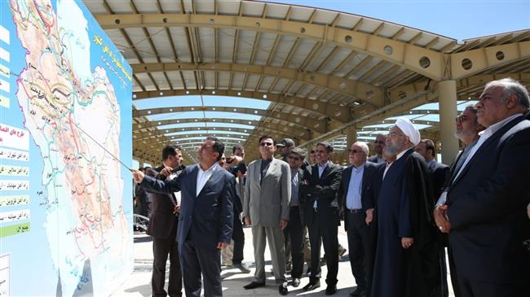 Director of the project Nureddin Gandomi points to the map as President Rouhani and Minister of Petroleum Bijan Zangeneh look on. (Photo by IRNA)
Kermanshah is the latest remaining provincial capital to join the national railway network. The cities of Rasht and Urmia are next to connect with the grid in the coming months, before Ardabil, Sanandaj and Bushehr round up the plan.
Railway expansion
On Sunday, Minister of Roads and Urban Development Abbas Akhundi said Iran needed $50 billion of investment for the modernization and expansion of its railway network in the next 10 years.
“The development of the rail network is far behind the roads network in Iran, and we have a big gap in this area, while rail transport is safe, healthy, green and environment friendly,” he said.
“We have proposed that all the provincial capitals join the rail network by the end of the 12th administration (in 2021), and that we experience the development of railway-based cities where we will witness the expansion of suburban rails in major cities for the first time,” Akhundi added.
Iran plans to stretch out its nationwide railroad line to 25,000 kilometers by 2025 from under 15,000 kilometers now.
In recent years, the country has signed a number of railway expansion or modernization agreements with foreign companies.
Early this month, China’s CRRC Nanjing Puzhen Rail Transport signed a contract with Iran’s IDRO Group to supply 450 metro cars for the Iranian cities of Ahvaz, Tabriz and Shiraz.
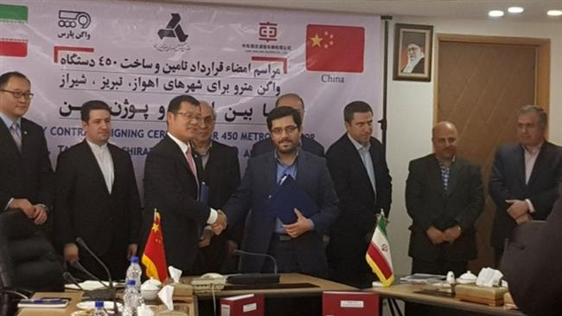
PressTV-China's railway giant signs Iran metro cars deal
CRRC Nanjing Puzhen Rail Transport, a subsidiary of China’s railway giant CRRC Corps, undertook to provide funds up to 85% of the project as well as parts for assembly in Iran.
Another Chinese company signed a deal with Iran's Ministry of Roads and Urban Development to build a railway between the cities of Shiraz and Bushehr in the country's south with $700 million of investment.
In July 2017, Iran’s state rail company and its Italian counterpart signed a final agreement worth 1.2 billion euros ($1.37 billion) to build a high-speed railway between the cities of Qom and Arak.
Later that month, French transport company Alstom signed a joint agreement for the construction of subway carriages in Iran.

